Annika Rockenberger and Jens-Morten Hanssen, University of Oslo

## Perceptions of Truth/Untruth in Ibsen Criticism

“Who will vouch for it that two and two do not make five up in Jupiter?” Ibsen asks in one of his letters to Georg Brandes, quite literally questioning the very concept of universal truth.[1] On a prominent page in *An Enemy of the People*, Dr. Stockmann claims: “The life of a normally constituted truth is generally, say, about seventeen or eighteen years, at most twenty; rarely longer”, thereby contradicting the very concept of eternal truth.[2] Ironically, Ibsen’s critics take a less critical stance on commonplace conceptions of truth. References to truth in its various linguistic variants are in abundance in Ibsen criticism, especially as practiced in Ibsen’s own lifetime. But with what kind of truth do Ibsen critics operate? Truth seems to prevail in ways distinct from, on the one hand, the way characters in Ibsen’s works – like Dr. Stockmann – pronounce it, and on the other hand, the manner in which we normally use the notion of truth in everyday language.

In this paper, we will interrogate the rhetoric of truth – and its counterpart untruth – as employed by critics in 604 book and theatre reviews of Ibsen’s works from the period 1850-1906. The reviews stem from newspapers and journals in Norway, Denmark, Sweden, Germany, England and France, allowing us to look into the critical reception of Ibsen’s works across national borders and from a multilingual perspective. Digitized as part of the Ibsen.nb.no website project at the National Library of Norway, the reviews have been examined with tools for computer-aided text analysis, enabling us to search for patterns not discernible by studying each review individually.

Looking up entries in major dictionaries across languages and time leaves the impression of a well-defined term with a stable meaning: truth signifies more or less the same today as in 1850, and more or less the same for Scandinavians as for Brits and Germans (cf. *Ordbog over det danske Sprog*, *Oxford English Dictionary*, *Deutsches Wörterbuch*). According to two relevant big data collections, however, there are striking variations when it comes to frequency of the word in printed sources from a longer time span. Figures 1 and 2 below display the frequency of *truth* in Google Books and of *sandhed/sannhet* (the spelling changed in the 1920s) in the digital collection of the National Library of Norway.

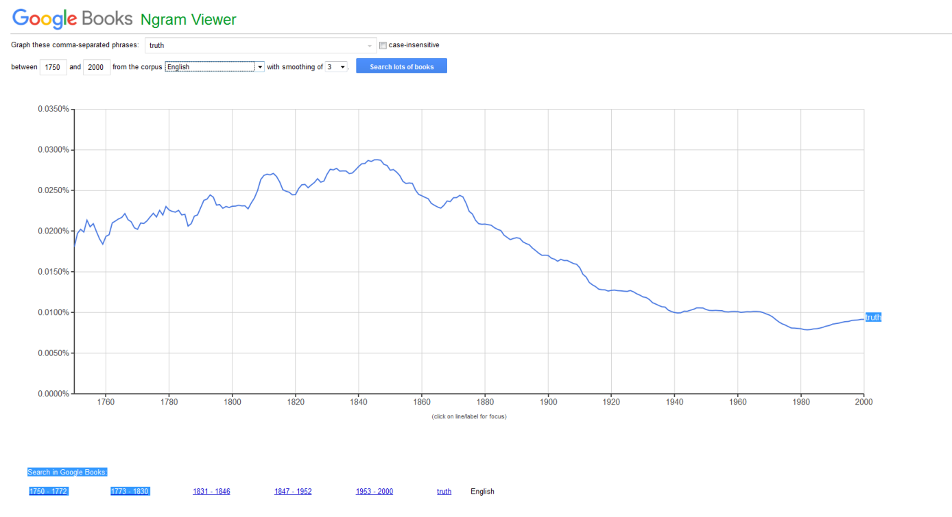

*Figure 1: Frequency of* truth *1750-2000 according to Google Books Ngram Viewer*

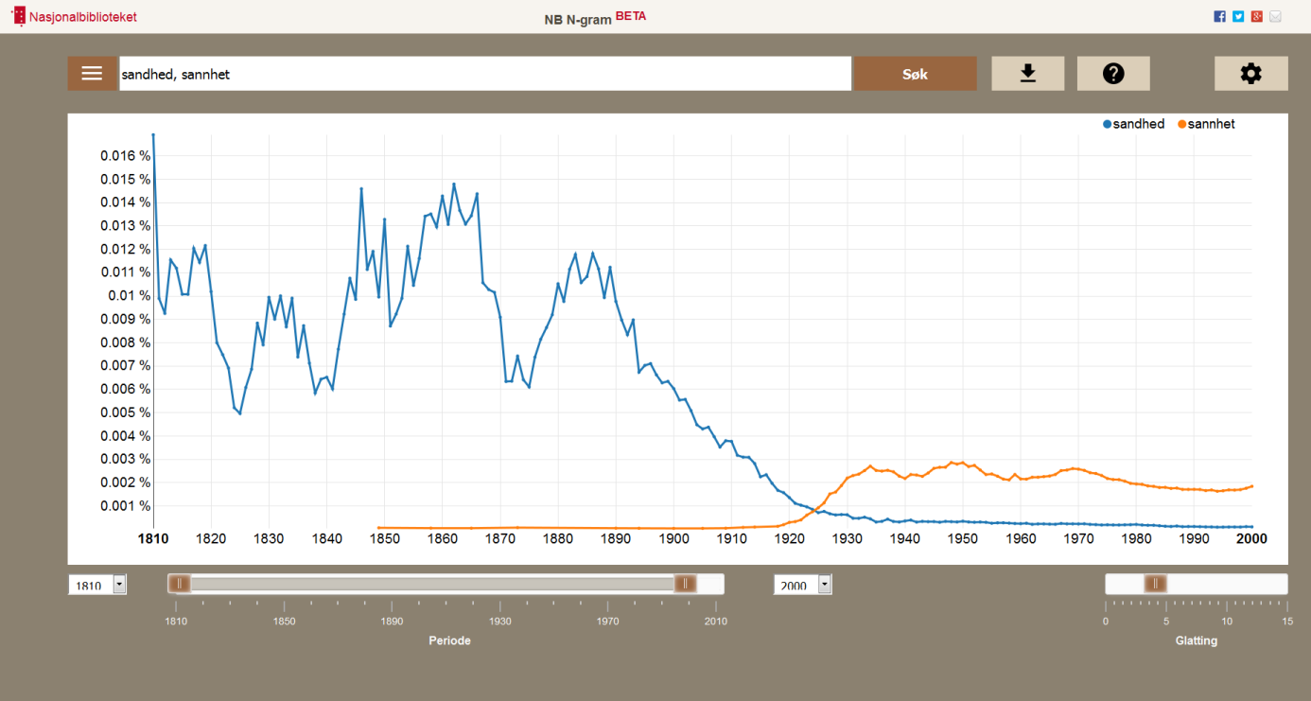

*Figure 2: Frequency of* sandhed/sannhet *1810-2000 according to NB N-gram*

According to the line chart of figure 2, the frequency of *sandhed* in 1850, as Ibsen made his debut, was 4.6 times higher than the frequency of *sannhet* in 1950. The English-language corpus of Google Books indicates that the frequency of *truth* was 2.7 times higher in 1850 as in 1950.[3] Thus, in terms of volume of use, we have to bear in mind that the 19th century, Ibsen’s century, had a stronger fixation with truth than the following century. The lexical meaning remaining stable over time, we nevertheless must assume that critics of Ibsen’s lifetime and critics of today, discussing the same subject matter, f. i. a theatre production of *An Enemy of the People*, use a different jargon and operate with different terms, the former showing a stronger disposition to use a notion like truth whereas the latter would avoid it.

Searching the entire corpus of 604 reviews comprising 1,020,202 words, 83,302 of which are unique words, using Voyant Tools ([voyant-tools.org](http://voyant-tools.org/) & [beta.voyant-tools.org](http://beta.voyant-tools.org/)), the number of occurrences for the various forms of the Dano-Norwegian lexemes for truth, true, untruth, and untrue are 547, 447, 44, and 40 respectively.

|  |  |  |  |  |
| --- | --- | --- | --- | --- |
| Word | Occurrences |  | Word | Occurrences |
| *sandhed* | 273 |  | *sandt* | 177 |
| *sandheden* | 116 |  | *sand* | 133 |
| *sandheder* | 80 |  | *sande* | 122 |
| *sandhedens* | 61 |  | *sandere* | 13 |
| *sandheds* | 10 |  | *sandeste* | 2 |
| *sandhederne* | 5 |  | *sandest* | 1 |
| *sandhedernes* | 2 |  | Sum | 447 |
| *sandheders* | 1 |  |  |  |
| Sum | 547 |  |  |  |

|  |  |  |  |  |
| --- | --- | --- | --- | --- |
| Word | Occurrences |  | Word | Occurrences |
| *usandhed* | 33 |  | *usande* | 15 |
| *usandheden* | 8 |  | *usandt* | 14 |
| *usandheder* | 3 |  | *usand* | 11 |
| Sum | 44 |  | Sum | 40 |

In addition come numerous (but low-frequent) compounds like *sandhedsvidne* (5), *forpostsandhed* (4), *natursandhed* (3), *sandhedskjærlig* (3), *sandhedssøgende* (3), *livssandhed* (2), *sandhedskrav* (2), *sandhedspathos* (2), *flertalssandheder* (1), *grundsandheden* (1), *ikke-sandheder* (1), *sandhedsideal* (1), *sandhedserkjendelse* (1), *sandhedsiver* (1), *sandhedsmartyr* (1), *sandhedsløs* (1), *sandhedstrang* (1), *trossandheder* (1), *verdenssandhed* (1).

|  |  |
| --- | --- |
| Word | Occurrences |
| *Ibsen* | 2414 |
| *livet* | 605 |
| *verden* | 427 |
| *virkelig* | 379 |
| *kvinde* | 299 |
| ***sandhed*** | **273** |
| *skyld* | 264 |
| *menneske* | 242 |
| *moderne* | 210 |
| *samfund* | 190 |
| *ægteskab* | 161 |

Focusing on the lemma *truth* (*sandhed*) exclusively, we notice that it has a higher frequency than f.i. *guilt* (*skyld*), *human* (*menneske*), *modern* (*moderne*), *society* (*samfund*), and *marriage* (*ægteskab*), and only a slightly lower frequency than f.i. *woman* (*kvinde*).

Distribution by time…

As the main bulk of reviews are in Dano-Norwegian, cf. pie chart to the left displaying the distribution according to language…

The multilanguage corpus of reviews has been made available as .html-files that we converted into .txt-files for further exploring them with tools for computer-aided text analysis. The provided meta data (date, publisher, publication, author, title of reviewed work) has been extracted separately and stored in a bibliographical database (Zotero). The corpus of reviews has then been divided by language into 5 subcorpora (Dano-Norwegian, Swedish, English, German, French).

Critics claim that a literary work (f.i. *Pillars of Society*) is a ‘true’ depiction of contemporary life or that a literary character (f.i. Hedda) possesses no ‘truth value’ or that the ending of a literary work (f.i. *A Doll’s House*) is ‘untruthful’. Critics use this notion in ways quite different from everyday usage, deprived of its connection to the realm of logic and objective facts. Throughout Ibsen’s life, his works were a site of contestation over aesthetic, literary, artistic and intellectual matters, cultural policy, and political ideology. Claims of truth/untruth are one of the strongest rhetorical devices used in these contestations.

For the analysis, we will, firstly, extract key words as well as their collocations and their frequencies over time with Voyant tools ([voyant-tools.org](http://voyant-tools.org/) & [beta.voyant-tools.org](http://beta.voyant-tools.org/)) for each subcorpus and for the corpus as a whole. The focus will expecially be on notions of ’truth/untruth’ in their different linguistic forms: truth/untruth, true/untrue, truthful/untruthful, Wahrheit/Unwahrheit, wahr/unwahr, wahrhaft/unwahrhaft, sandhed/usandhed, sand/usand, sandfærdig/usandfærdig, sanning/osanning, sann/osann, sannfärdig/osannfärdig, vérité/contre-vérité, vrai/faux, etc. We will then look at the underlying semantic structures (topic modeling) with MALLET ([http://mallet.cs.umass.edu](http://mallet.cs.umass.edu/)) as well as Papermachines ([http://mallet.cs.umass.edu](http://mallet.cs.umass.edu/)) and relate them to Ibsen’s works, to the critics, the journals and newspapers, and the different nations to search for patterns of correlation and co-occurance and thus hope to shed some light on the critical reception of Ibsen during his lifetime across national and linguistic borders.

1. *The Correspondence of Henrik Ibsen*. Translation edited by Mary Morison. (New York: Haskell, 1970), p. 209.
2. *The Oxford Ibsen*, vol. 6 (*An Enemy of the People*; *The Wild Duck*; *Rosmersholm*). Edited and translated by James Walter McFarlane. (London: Oxford University Press, 1960), p. 97.
3. Selecting the German-language corpus of Google Books, the Ngram Viewer generates a line chart displaying the same overall tendency.